**Randleman Fire Department in cooperation with Randolph Community College**

**emergency Services Training**

**Course announcement**

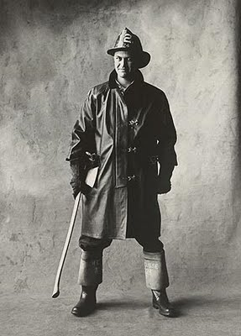

National Fire Academy

Leadership IN SUPERVISION

“PERSPECTIVES IN THINKING”

**June 19th, 21st, 26th and 28th 2023**

**1800 hours until 2200 hours**

**Class location is Randleman Fire**

**Class size is limited RCC requests that all participants pre-register by emailing**

**rlbrewer@randolph.edu or dscallicutt@randolph.edu**