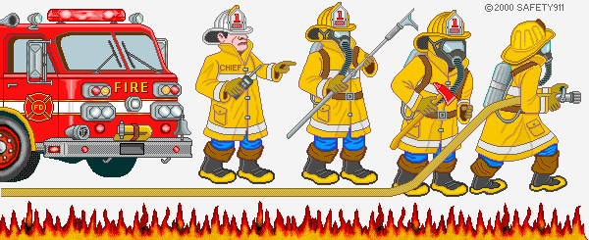**Randleman Fire Department in cooperation with Randolph Community College**

**emergency Services Training**

**Course announcement**



National Fire Academy

Leadership In SUPERVISION

*“Creating Environments for Professional Growth”*

**May 9th, 11th, 18th and 22nd 2023**

**1800 hours until 2200 hours**

**Class location is Randleman Fire**

**Class size is limited RCC requests that all participants pre-register by emailing**

[**rlbrewer@randolph.edu**](mailto:rlbrewer@randolph.edu) **or dscallicutt@randolph.edu**