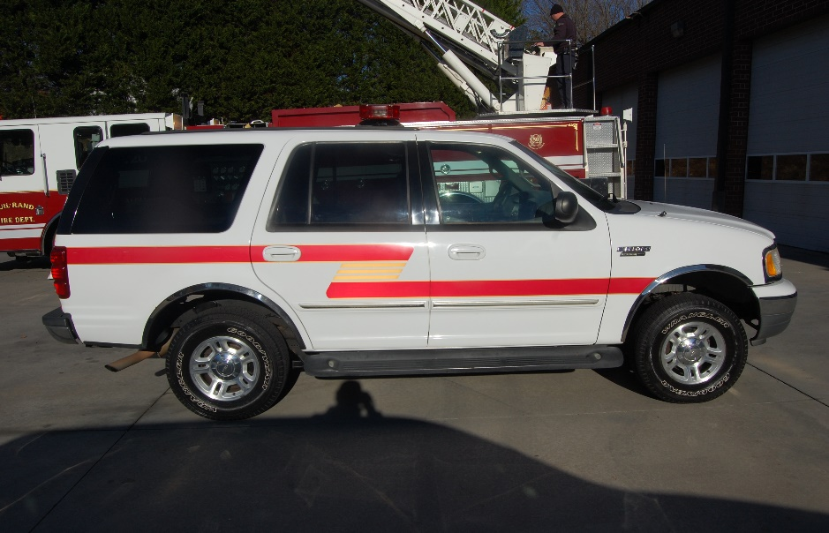**For Sale**

**2001 Ford Expedition Triton 5.4L Engine**

**4-Wheel Drive**

**192,545 Miles**

**Power Locks, Windows and Mirrors**

**3rd Row seat**

**Serviced Regularly**

**Runs and looks great**

**Stripping, Emergency Lights, and Siren**

**Selling As Is $3000.00**

If interested contact Chief Chris White 336-431-2512 at Guil-Rand Fire Department

