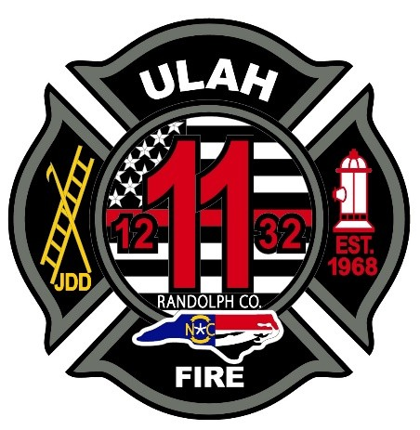
Ulah Volunteer Fire Department
2067 Pisgah Covered Bridge Rd.
Asheboro, N.C. 27205
Phone: (336) 629-1966

Position: Firefighter
Starting Salery: $40,000 for non-certified applicants
$42,000 for certified applicants
Closing Date: Open until filled

Part Time Positions are also Available with pay of $16 per hour daytime
and $17 per hour nighttime and weekends.

Benefits:
- Pay Increases at 6 months and Annually
- Paid Medical, Dental, and Vision Insurance
- SEP Contribution of 6% Retirement Plan
- Training and Education Incentives
- Paid Vacation, Holiday, and Sick Leave

Job Requirements:
- N.C. EMR or Higher Medical Certification required for consideration for employment
- Firefighters in this position will work a Kelly schedule shift that requires them to work on weekends and holidays. Example 24 on, 24 off, 24 on, 24 off, 24 on, 96 off
- Firefighters in this position may be required to work in environments with extremely hot and cold temperatures.
- Firefighters in this position may work in situations that may present immediate dangers to the individual’s life and health.
- Firefighters in this position must work well and communicate well with others while performing daily operations of the department.

Minimum Qualifications for Certified Applicants:
- N.C. Certified Firefighter
- N.C. Hazardous Materials Operations Level I
- N.C. Emergency Vehicle Driver
**Non-Certified Applicants will be required to obtain minimum qualifications within one year of employment. **

All Applicants must have a high school diploma or GED Certificate.

*All Applicants must possess a valid N.C. Driver’s License and must obtain a Class B license within 6 months of employment. *

Applications may be picked up at Ulah Fire Department Station 11
2067 Pisgah Covered Bridge Rd. Asheboro, N.C. 27205
Ulah Volunteer Fire Department is an Equal Opportunity Employer

