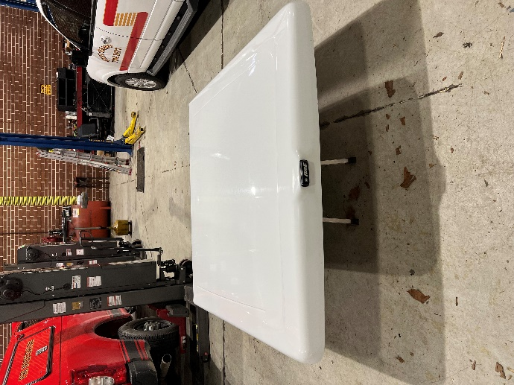**For Sale**

## **Used 5’8” Fiberglass**

## **ARE truck bed cover**

## **for 14-18 Chevy Silverado**

**Locks and is in great condition**

**Selling as Is $500.00**

If interested contact Assistant Chief Chris White 336-431-2512 at Guil-Rand Fire Department

