REPORTING MANAGEMENT SOFTWARE

A key component of administrative & technical infrastructure. It enables state reporting, historic records, and collects data.

BENEFITS

* No cost to NC Fire/Rescue Departments or County Agencies
* No downloads or installs
* Automatically reports to the state
* OSFM will handle exports to FEMA
* Access from any device with internet service

EXTRA PURCHASE OPTIONS

* CAD Integration

SUPPORT

Submit a support ticket online at support.imagetrend.com OR give us a call at 888-730-3255 Monday-Friday from 8:30 a.m. to 5:00 p.m. CST.

REQUEST A DEMO

<https://www.imagetrend.com/who-we-serve-fire/>

If you have questions about incident reporting, please call Monna Gillespie at 1-800-634-7854 or 919-647-0088, or email monna.gillespie@ncdoi.gov

**IMAGE TREND ELITE**

**Issues with your NFIRS and Reporting Management Software (RMS)? Need something less expensive or the ability to do more? OSFM can help.**

**OSFM IS UPGRADING OUR RMS**

OSFM is upgrading our Image Trend/Fire Bridge RMS to Image Trend Elite – Go Live date is scheduled for July 12, 2021.

* This will remain FREE to North Carolina Fire and Rescue Agencies
* Includes NFIRS, activities/training, checklist, documents, fire shifts, hydrants, inventory, permits, locations/occupants, and inspection.
* This upgrade will alleviate storage issues, outages for DOI maintenance, and other issues associated with DOI hosting the software.
* Ifyou are currently using Fire Bridge, your data will be migrated over. All NFIRS data will be moved regardless of your RMS provider.

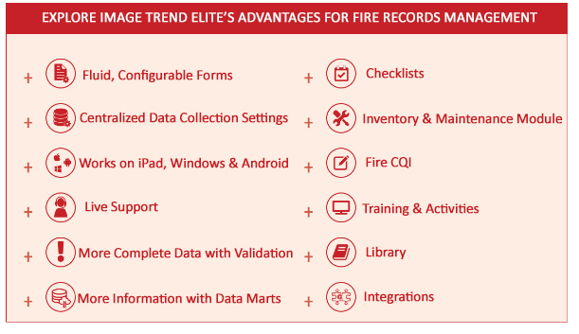More details regarding the upgrade will be forwarded to you once the date is finalized.

**WHAT IS ELITE?**

Springdale Fire Dept., AR

Surprise Fire Dept., AZ

Arizona Fire & Medical Authority, AZ

City of Yuma Fire Dept., AZ

Kingman Fire Dept., AZ

Yocha Dehe Fire Dept., CA

Poudre Fire Authority, CO

Pueblo Fire Dept., CO

Atlanta Fire Dept., GA

Clayton Co. Fire & Emerg. Services, GA

Cobb Co. Fire & Emerg. Services, GA

Columbus Dept. of Fire & Emer. Medical Services, GA

LaGrange Fire Dept., GA

Orland Fire Protection District, IL

Skokie Fire Dept., IL

Louisville Division of Fire, KY

Grand Rapids Fire Dept., MI

Central Jackson Co. Fire Protection District, MO

Greenville Fire/Rescue, NC

Washington Township Fire Dept., OH

Bristol Tennessee Fire Dept., TN

El Paso Fire Dept., TX

Houston Fire Dept., TX

Charlottesville Fire Dept., VA

City of Roanoke Fire-EMS Dept., VA

Danville Fire Dept., VA

Fairfax Co. Fire and Rescue Dept., VA

Hampton Division of Fire & Rescue, VA

Virginia Beach Fire Dept., VA

West Allis Fire Dept., WI

**Accredited fire departments using image trend elite**

**ImageTrend Elite**™ is the gold standard of electronic documentation and reporting. It was developed with the user in mind, with a fluid interface optimized across multiple platforms and operating systems.

Elite contains all the modules that Fire Bridge did, including Reporting, NFIRS-compliant data collection, Permits, Inspections, Investigations, Repairs & Maintenance, and Checklists, but is built on next-generation technology. Elite has a much more modern feel than the Fire Bridge site, making it far more intuitive and user-friendly. It’s compatible with numerous browsers and devices, including tablets and iPads!

