May 22, 2023

Notice of Proposed Budget Meeting

The Randolph County Board of Commissioners will hold a Proposed Budget meeting on Monday, June 12th starting at 4 pm. At this time, the Commissioners will hear budget requests from community agencies. Any fire department that wishes to address the Board about the requested tax rate for the upcoming fiscal year may do so at this time. Please call if you wish to book a time slot.

The statutorily required Public Hearing on the Proposed Budget is scheduled the same evening. Adoption of the Budget is scheduled for Monday, June 19th at 6 pm.

If you have any questions, please call Dana Crisco or Jenny Parks at 336-318-6301.

Thank you,

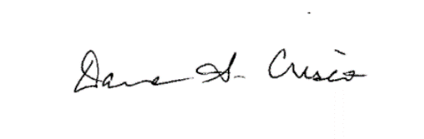

Dana Crisco

Clerk to the Board

Randolph County Board of Commissioners