**Randleman Fire Department in cooperation with Randolph Community College**

**emergency Services Training**

**Course announcement**

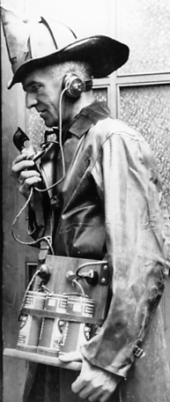

National Fire Academy

Leadership In SUPERVISION

“FRAMEWORK TO SUCCESS”

**July 11th, 13th, 20th and 24th 2023**

**1800 hours until 2200 hours**

**Class location is Randleman Fire**

**Class size is limited RCCC requests that all participants pre-register by emailing**

rlbrewer@randolph.edu or dscallicutt@randolph.edu