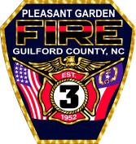
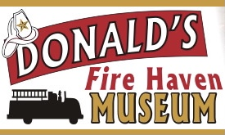
DONALD’S FIRE HAVEN MEMORIAL
GOLF TOURNAMENT
SPONSORSHIP FORM

SPONSOR LEVELS
FULLY INVOLVED $3,000 - $5,000  2 teams (8 players)  Hole Sponsor Sign w/name  Recognition in program and at awards  Name/logo on display banner at Country Club  SMOKE SHOWING $750 - $1,500  1 team (4 players)  Hole Sponsor Sign  Recognition in program (name only) | WORKING FIRE $1,600 - $2,500  1 team (4 players)  Hole Sponsor Sign w/name  Recognition in program w/logo and at awards  Contest Sponsor $250  Logo/Name on banner at contest hole  Hole Sponsor $100  Sign w/name at hole

Choose one:

___ Fully Involved ___ Smoke Showing ___Working Fire

___Contest Sponsor ___ Hole Sponsor

NAME/COMPANY NAME _______________________________________

CONTACT PERSON __________________________________________

ADDRESS __________________________________________________

PHONE _________________________

EMAIL _____________________________________

NAME TO BE PRINTED ON SIGN
_____________________________________________________

Email company logo to cgarrett@pgfd3.com

Make checks payable to Donald’s Fire Haven Museum
Memo: Museum

Mail form and payment to
PGFD Museum
PO Box 710
Pleasant Garden, NC 27313

In the event of cancellation, all donations are final and non-refundable.

