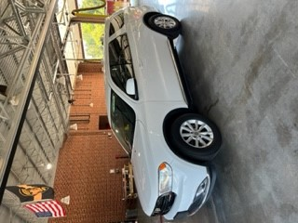**For Sale**

**2015 Dodge Durango**

**All-Wheel Drive**

**62,000 Miles**

**Power Locks, Windows and Mirrors**

**Serviced Regularly**

**Runs and looks great**

**Emergency Lights and Siren**

**Selling as Is $25,000.00**

If interested contact Assistant Chief Chris White 336-431-2512 at Guil-Rand Fire Department

