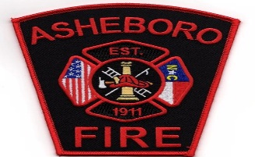 ASHEBORO FIRE DEPARTMENT

DATE: 01/12/2022

TO: Public Release

FROM: Chief Cockman

RE: Chief Hoover Funeral Procession

Any department that would like to have a truck in the funeral procession for Chief Hoover will need to be at Asheboro Fire Department located at 401 S. Church St on 01/14/2022 by 10:30 AM. We ask that you line up south of the station's front ramp headed north in the turn lane of Church St. The procession will leave at 11:00 AM. We will head north on Church St., turn right onto Sunset Ave., then right onto S. Fayetteville St., proceed on S. Fayetteville St., to Walker Ave., take a right onto Walker Ave., then a left onto Park St., then a right onto W. Dixie Dr. We will then take Dixie Dr./ Hwy 64 w to Robbins Cir.

All of the Asheboro Fire Departments' trucks will turn into the church's parking lot, and we ask that the first truck behind them proceed to the stop sign of Robbins Circle and Hoover Hill Rd. and start parking in the right-hand lane. We will be using the Randolph County Mutal Aid Channel for radio traffic.