**Updated COVID-19 Guidance & Information for Businesses**

***\*Current as of 1/6/2022***

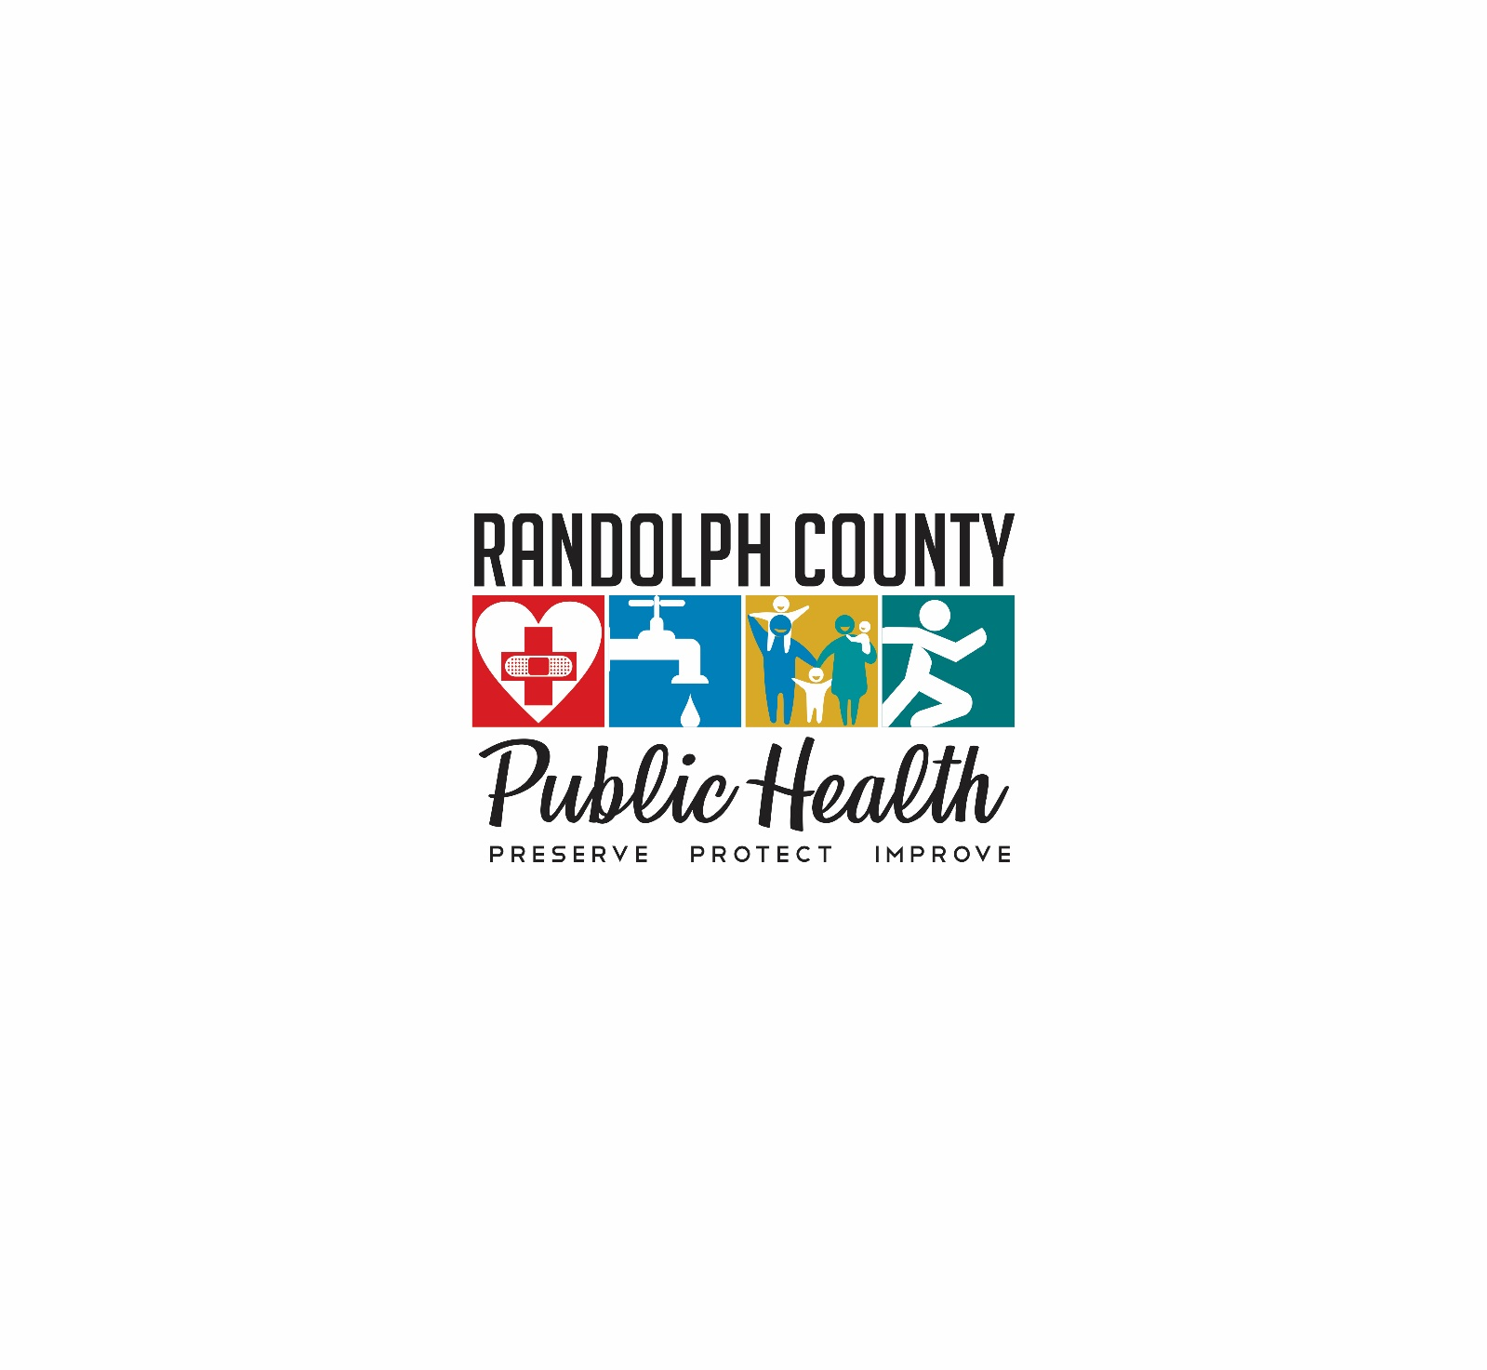

**Updated by  
Melissa Thomson, NBC-HWC  
RCPH COVID-19 Business Liaison  
2222-B S. Fayetteville Street   
Asheboro, NC 27205  
Phone: 336-318-6754  
Email:** [**melissa.thomson@randolphcountync.gov**](mailto:melissa.thomson@randolphcountync.gov)

**Testing**

[**Who should get tested**](https://www.cdc.gov/coronavirus/2019-ncov/testing/diagnostic-testing.html)**? – Current Guidance as of 1/5/2022**

* People who have [symptoms of COVID-19](https://www.cdc.gov/coronavirus/2019-ncov/symptoms-testing/symptoms.html).
* People who have come into [close contact](https://www.cdc.gov/coronavirus/2019-ncov/php/contact-tracing/contact-tracing-plan/appendix.html) with someone with COVID-19
  + People who have been exposed regardless of vaccination status should be tested on day 5 after exposure, click [here](https://www.cdc.gov/coronavirus/2019-ncov/your-health/quarantine-isolation.html) for quarantine guidance
* People not fully vaccinated with COVID-19 vaccine who are prioritized for expanded [community screening](https://www.cdc.gov/coronavirus/2019-ncov/hcp/testing-overview.html) for COVID-19.
* People not fully vaccinated with COVID-19 vaccine who have been asked or referred to get testing by their school, workplace, healthcare provider.

**Symptoms of COVID-19**

People with COVID-19 have had a wide range of symptoms reported – ranging from mild symptoms to severe illness. Symptoms may appear 2-14 days after exposure to the virus. Anyone can have mild to severe symptoms. People with [these symptoms](https://www.cdc.gov/coronavirus/2019-ncov/symptoms-testing/symptoms.html) may have COVID-19:

* Fever or chills
* Cough
* Shortness of breath or difficulty breathing
* Fatigue
* Muscle or body aches
* Headache
* New loss of taste or smell
* Sore throat
* Congestion or runny nose
* Nausea or vomiting
* Diarrhea

This list does not include all possible symptoms. CDC will continue to update this list as they learn more about COVID-19. Older adults and people who have severe underlying medical conditions like heart or lung disease or diabetes seem to be at higher risk for developing more serious complications from COVID-19 illness.

**Testing Locations & Information– *Current as of 1/3/2022****\*Please note, this is not an all-inclusive list of testing sites located within Randolph County. Please visit NC DHHS Find My Testing Place to find the nearest COVID-19 testing place for your location.*

* **NC DHHS *Find My Testing Place:***To order at-home test kits, or to find the nearest COVID-19 testing site, visit [https://covid19.ncdhhs.gov/about-covid-19/testing/find-my-testing-place](https://covid19.ncdhhs.gov/about-covid-19/testing/find-my-testing-place%20)
* **StarMed (3 sites in Randolph County)***\*\*Preregistration is not required, but is strongly recommended. Visit* [*https://starmed.care/*](https://starmed.care/) *or text the word COVID to 704-850-6996 to preregister\*\*****NOTE:******Inclement weather & holiday’s may impact operation*  
    
  First United Methodist Church (Asheboro)**224 N. Fayetteville Street Asheboro, NC 27203  
  **Hours of operation:**Monday-Friday 12p-6p, Saturday 11a-2p **Randolph Community College – Archdale location**110 Park Drive Archdale, NC 27263  
  **Hours of operation:**Tuesday & Thursday *only* 10a-2p  
    
  **Randolph Community College – Asheboro location**629 Industrial Park Avenue Asheboro, NC 27205  
  **Hours of operation:**Monday, Wednesday & Friday *only* 3p-7p  
    
  **Cost:**If insured, patient will be asked to provide medical insurance information during the registration process.

If uninsured, cost will be filed under the CARES Act and will be provided at no-cost to the patient.  
  
**Testing availability (based on supply):**Rapid antigen (symptomatic patients)  
PCR

Flu

* **Central Piedmont Urgent Care (2 locations)**   
  **Randleman Location**  
  1011 High Point Street Randleman, NC 27317  
  336-498-0226

**Siler City Location**  
101 Walmart Supercenter Siler City, NC 27344  
919-663-3911

**Hours of operation:**Monday-Friday 8a-8p  
Saturday 8a-6p  
Sunday 10a-6p

**Cost:** If patient has insurance coverage, they must bring a copy of insurance card and valid photo ID (driver’s license).

If patient is uninsured, as long as they are able to provide a valid photo ID (driver’s license) **AND** have a SSN (Social Security Number), any cost associated with COVID-19 (visit & testing charge) will be filed under the CARES Act and will be provided at no-cost to the patient.  
  
**Testing availability (based on supply):**Rapid antigen  
PCR

**For more information**, please visit <https://www.centralpiedmonturgentcare.com/>

* **White Oak Urgent Care (2 locations)  
  Asheboro location**197 North Carolina 42 Asheboro, NC 27203  
  336-625-2560  
    
  **Randleman location**  
  608 West Academy Street Randleman, NC 27317  
  336-495-1001  
    
  **Hours of operation:**Monday-Friday 8a-8p  
  Saturday 9a-6p  
  Sunday 10a-6p  
  *\*Offices are closed on Easter, Thanksgiving, and Christmas Day***Cost:**If patient is insured, insurance will be billed and patient will be responsible for paying copay for Urgent Care visit. Additionally, there may be additional charges for rapid testing.  
    
  If patient is uninsured, patient will be responsible for paying office visit charge (minimum of $100) and any additional charge for testing, etc.  
    
  **Testing availability (based on supply):**Rapid antigen  
  PCR

**Isolation & Quarantine**

[**Isolation & Quarantine Guidance**](https://www.cdc.gov/coronavirus/2019-ncov/your-health/quarantine-isolation.html) **– *current as of 1/5/2022***

**If You Test Positive for COVID-19 (Isolate), everyone, regardless of vaccination status:**

* Stay home for 5 days.
* If you have no symptoms or your symptoms are resolving after 5 days, you can leave your house. *Must be fever free for 24 hours without use of fever reducing medication.*
* Continue to wear a mask around others for 5 additional days.

*If you have a fever, continue to stay home until your fever resolves.*

**If You Were Exposed to Someone with COVID-19 (Quarantine)**

***Who Does NOT Need to Quarantine***If you came into close contact with someone with COVID-19 and you are in one of the following groups, you do not need to quarantine.

* You are ages 18 or older and have received all [recommended vaccine doses](https://www.cdc.gov/coronavirus/2019-ncov/vaccines/booster-shot.html), including [boosters](https://www.cdc.gov/coronavirus/2019-ncov/vaccines/booster-shot.html) and [additional primary shots](https://www.cdc.gov/coronavirus/2019-ncov/vaccines/recommendations/immuno.html) for some immunocompromised people.
* You are ages 5-17 years and completed the [primary series](https://www.cdc.gov/vaccines/covid-19/clinical-considerations/covid-19-vaccines-us.html?CDC_AA_refVal=https%3A%2F%2Fwww.cdc.gov%2Fvaccines%2Fcovid-19%2Finfo-by-product%2Fclinical-considerations.html#children) of COVID-19 vaccines.
* **You had confirmed COVID-19 within the last 90 days (you tested positive using a**[**viral test**](https://www.cdc.gov/coronavirus/2019-ncov/symptoms-testing/testing.html)**).**

You should wear a [well-fitting mask](https://www.cdc.gov/coronavirus/2019-ncov/your-health/effective-masks.html) around others for 10 days from the date of your last close contact with someone with COVID-19 (the date of last close contact is considered day 0). [Get tested](https://www.cdc.gov/coronavirus/2019-ncov/testing/diagnostic-testing.html) at least 5 days after you last had close contact with someone with COVID-19. If you test positive or develop COVID-19 symptoms, isolate from other people and follow recommendations in the [Isolation](https://www.cdc.gov/coronavirus/2019-ncov/your-health/quarantine-isolation.html#_Isolation) section below. If you tested positive for COVID-19 with a [viral test](https://www.cdc.gov/coronavirus/2019-ncov/symptoms-testing/testing.html) within the previous 90 days and subsequently recovered and remain without COVID-19 symptoms, you do not need to quarantine or get tested after close contact. You should wear a [well-fitting mask](https://www.cdc.gov/coronavirus/2019-ncov/your-health/effective-masks.html) around others for 10 days from the date of your last close contact with someone with COVID-19 (the date of last close contact is considered day 0).

***Who Should Quarantine***

If you come into close contact with someone with COVID-19, you should quarantine if you are in one of the following groups:

* You are ages 18 or older and completed the [primary series](https://www.cdc.gov/vaccines/covid-19/clinical-considerations/covid-19-vaccines-us.html?CDC_AA_refVal=https%3A%2F%2Fwww.cdc.gov%2Fvaccines%2Fcovid-19%2Finfo-by-product%2Fclinical-considerations.html) of recommended vaccine, but have not received a [recommended](https://www.cdc.gov/coronavirus/2019-ncov/vaccines/booster-shot.html) booster shot when eligible.
* You received the single-dose Johnson & Johnson vaccine (completing the primary series) over 2 months ago and have not received a [recommended](https://www.cdc.gov/coronavirus/2019-ncov/vaccines/booster-shot.html) booster shot.
* You are not vaccinated or have not completed a [primary vaccine series](https://www.cdc.gov/vaccines/covid-19/clinical-considerations/covid-19-vaccines-us.html?CDC_AA_refVal=https%3A%2F%2Fwww.cdc.gov%2Fvaccines%2Fcovid-19%2Finfo-by-product%2Fclinical-considerations.html).

***What to do for Quarantine***

* Stay home and away from other people for at least 5 days (day 0 through day 5) after your last contact with a person who has COVID-19. The date of your exposure is considered day 0. Wear a [well-fitting mask](https://www.cdc.gov/coronavirus/2019-ncov/your-health/effective-masks.html) when around others at home, if possible.
* For 10 days after your last close contact with someone with COVID-19, watch for fever (100.4◦F or greater), cough, shortness of breath, or other [COVID-19 symptoms](https://www.cdc.gov/coronavirus/2019-ncov/symptoms-testing/symptoms.html) .
* If you develop symptoms, [get tested](https://www.cdc.gov/coronavirus/2019-ncov/testing/diagnostic-testing.html) immediately and isolate until you receive your test results. If you test positive, follow [isolation](https://www.cdc.gov/coronavirus/2019-ncov/your-health/quarantine-isolation.html#isolation) recommendations.
* If you do not develop symptoms, [get tested](https://www.cdc.gov/coronavirus/2019-ncov/testing/diagnostic-testing.html) at least 5 days after you last had close contact with someone with COVID-19.
  + If you test negative, you can leave your home, but continue to wear a [well-fitting mask](https://www.cdc.gov/coronavirus/2019-ncov/your-health/effective-masks.html) when around others at home and in public until 10 days after your last close contact with someone with COVID-19.
  + If you test positive, you should isolate for at least 5 days from the date of your positive test (if you do not have symptoms). If you do develop [COVID-19 symptoms](https://www.cdc.gov/coronavirus/2019-ncov/symptoms-testing/symptoms.html), isolate for at least 5 days from the date your symptoms began (the date the symptoms started is day 0). Follow recommendations in the [isolation](https://www.cdc.gov/coronavirus/2019-ncov/your-health/quarantine-isolation.html#_Isolation) section below.
  + If you are unable to get a test 5 days after last close contact with someone with COVID-19, you can leave your home after day 5 if you have been without [COVID-19 symptoms](https://www.cdc.gov/coronavirus/2019-ncov/symptoms-testing/symptoms.html) throughout the 5-day period. Wear a [well-fitting mask](https://www.cdc.gov/coronavirus/2019-ncov/your-health/effective-masks.html) for 10 days after your date of last close contact when around others at home and in public.
  + Avoid people who are [immunocompromised or at high risk for severe disease](https://www.cdc.gov/coronavirus/2019-ncov/need-extra-precautions/people-with-medical-conditions.html), and nursing homes and other high-risk settings, until after at least 10 days.
* If possible, stay away from people you live with, especially people who are at [higher risk](https://www.cdc.gov/coronavirus/2019-ncov/need-extra-precautions/index.html) for getting very sick from COVID-19, as well as others outside your home throughout the full 10 days after your last close contact with someone with COVID-19.
* If you are unable to quarantine, you should wear a [well-fitting mask](https://www.cdc.gov/coronavirus/2019-ncov/your-health/effective-masks.html) for 10 days when around others at home and in public.
* If you are unable to wear a mask when around others, you should continue to quarantine for 10 days. Avoid people who are [immunocompromised or at high risk for severe disease](https://www.cdc.gov/coronavirus/2019-ncov/need-extra-precautions/people-with-medical-conditions.html), and nursing homes and other high-risk settings, until after at least 10 days.
* Do not travel during your 5-day quarantine period. Get tested at least 5 days after your last close contact and make sure your test result is negative and you remain without symptoms before traveling. If you don’t get tested, delay travel until 10 days after your last close contact with a person with COVID-19. If you must travel before the 10 days are completed, wear a [well-fitting mask](https://www.cdc.gov/coronavirus/2019-ncov/your-health/effective-masks.html) when you are around others for the entire duration of travel during the 10 days. If you are unable to wear a mask, you should not travel during the 10 days.
* Do not go to places where you are unable to wear a mask, such as restaurants and some gyms, and avoid eating around others at home and at work until after 10 days after your last close contact with someone with COVID-19.

***After Quarantine***

* Watch for symptoms until 10 days after your last close contact with someone with COVID-19.
* If you have symptoms, isolate immediately and [get tested](https://www.cdc.gov/coronavirus/2019-ncov/testing/diagnostic-testing.html).

[Click here](https://www.cdc.gov/coronavirus/2019-ncov/your-health/quarantine-isolation.html) for the updated quarantine and isolation guidance.

**Prevention**

**COVID-19 Prevention**

The best way to slow the spread of COVID-19 continues to be:

* Get vaccinated (including booster shot, if eligible) visit [*Find a Vaccine Location Near You*](https://covid19.ncdhhs.gov/vaccines)
* Wear a face covering indoors in public places, **regardless of vaccination status**
* Practice social distancing
* Stay home if you’re sick and get tested
* Test before and after traveling or when gathering with others not in your household
* Visit [*NCDHHS*](https://covid19.ncdhhs.gov/information/business/businesses-and-employers)for additional guidance, toolkits, and information