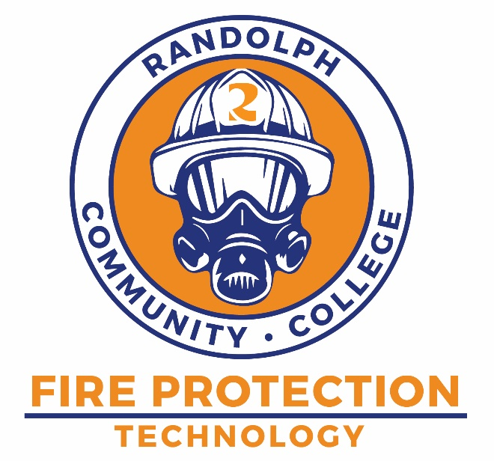
The Fire Protection Technology program is designed to provide the technical and professional knowledge needed for officer level decision making pertaining to fire protection for private and public sectors. It provides coursework in managerial and leadership areas necessary for promotion for existing firefighters as well as a solid foundation for continuing higher learning in the fire protection community.
Earn an Associate’s Degree through Randolph Community College that will assist in promotional opportunity within your chosen field. The 65-credit hour program has multiple options that allow credit for prior learning to help speed you from first class to degree in fewer classes. If you have FF I & II, Fire Officer I & II, D/O Pumps, Fire Inspections, EMT, or FLSE I, II, & III or any combination of these; you can receive credit towards your degree.
If you have any questions about the program:
Contact Robert King Department Head Fire Protection Technology
(336)736-9574
rbking@randolph.edu

FIRE PROTECTION TECHNOLOGY

randolph.edu

SACSCOC APPROVED

Course work includes diverse fire protection subject areas, including fire prevention and safety, public education, building construction, fire ground strategies and tactics, and local government finance and laws, as they apply to emergency services management. Emphasis includes understanding fire characteristics and the structural consequences of fire; risk assessment and management; and relevant research, communications, and leadership methodologies.

