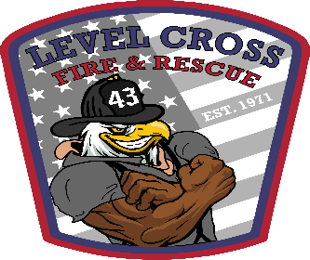

The Level Cross Fire Dept.

is accepting applications for part time employees.

**Application Period :**

**Closes on April 30, 2021**

**Job Description:**

The employee will be responsible for daily tasks of maintaining the fire station and the equipment associated with it (mowing grass, cleaning of station) as well as being able to respond to non-emergency as well as emergency calls. Equipment checks and basic maintenance of trucks and equipment and any other duties as needed by Fire Chief or any other immediate supervisor.

**Position & Hours:**

Part Time Fire fighter/Emt will be a 24hr shift starting @800am till 800am the next morning.

**Pay starts @ $11hr**

**Minimum Employment Requirements:**

Part Time FF/Emt – Must be 21 years of age , Certified Nc Firefighter, Emt-Basic, Emergency Vehicle Driver, Hazardous Materials Level 1 Responder, and possess a valid and current Class B driver’s license.

If interested feel free to contact Chief Ridgeway or Deputy Chief Brown @ 336-498-7141 for more info

Applications can be picked up at Level Cross Fire Dept @ 125 Branson Mill Rd. Randleman, NC 27317