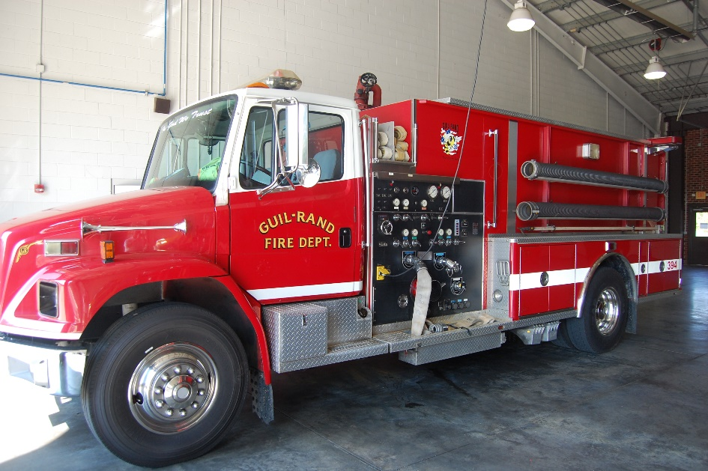**For Sale**

**1994 Freightliner Tanker**

**Cummins Engine (3565 Hours)**

**1250 Tank with 1000 GPM Hale Pump**

**44050 Miles**

**Serviced Regularly**

**Runs and looks great**

**Stripping, Emergency Lights and Siren**

**Selling As Is $40,000**

**If Interested contact Assistant Chief Chris White 336-431-2512 at Guil-Rand Fire Department**

