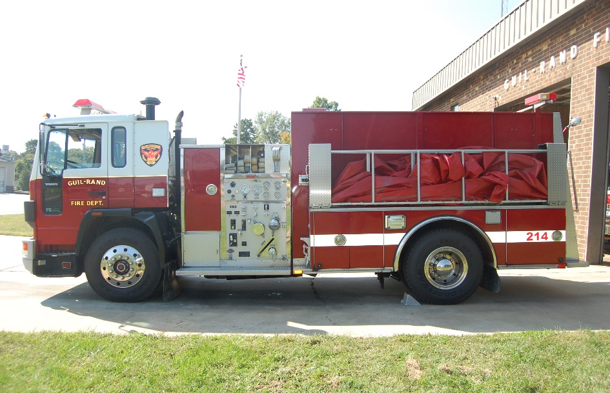**For Sale**

**1992 Volvo Tanker**

**1500 Tank with 500 GPM Pump**

**33500 Miles**

**Serviced Regularly**

**Runs and looks great**

**Stripping, Emergency Lights and Siren**

**Selling As Is $25000**

**If Interested contact Assistant Chief Chris White 336-431-2512 at Guil-Rand Fire Department**

