**Job Description**

**Job Title:**

Career Firefighter

**Nature of Work:**

Performs general firefighting duties in the areas of prevention, suppression and extinguishment of fires. Duties also require performing emergency medical care, performing rescue operations, and hazardous material responses as needed.

**Other Duties:**

* Operate emergency vehicles in accordance with state laws and departmental policy
* Perform daily/weekly vehicle and equipment inspections
* 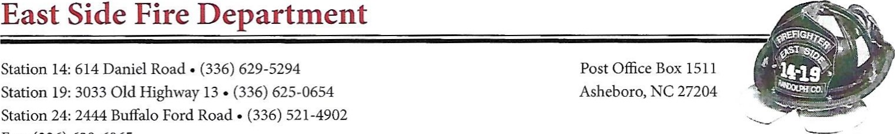Maintain the cleanliness of department facilities, trucks and equipment
* Assist with pre-fire planning, public information programs, and other special projects as directed by the Fire Chief
* Perform training as required by departmental certifications
* Accurately document required information on department forms and submit reports in accordance with departmental policy
* Demonstrate a professional attitude to include maintaining a professional appearance and acting in a courteous manner
* Work as an integral team player by interacting positively with other firefighters and automatic aid departments

**Supervision:**

Reports directly to the Fire Chief or his designee in regard to station duties and training issues. Works within the chain of command at emergency incidents. Paid personnel serve at the pleasure of the Chief of Department.

**Education:**

High school diploma or general education degree (GED)

**Certifications (Minimum):**

* NC Firefighter Il Certification
* NC Hazardous Materials Level I Certification (Operations Level)
* NC Medical Responder
* NC Emergency Vehicle Driver Certification
* Valid NC Class B Driver's License (within 30 days of hire)

**Preferred Certifications:**

* NC EMT-B Certification
* NC Driver-Operator Certification
* ICS 100, 200, 700

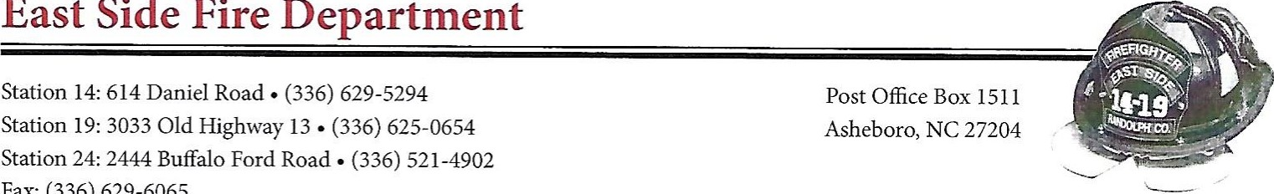**Physical Requirements:**

* Must be able to lift, move and climb ladders
* Must have the agility to climb through rafters, on roofs, or through tubes
* Must be able to open and close valves, hydrants and be able to advance a 1.75" hose line while discharging water
* Must be able to lift and carry heavy loads (100+ LBS) up and down stairs
* Must be able to drag hose (up to 5")
* Must be able to communicate effectively via two-way radio and over the telephone
* Must be able to grasp and safely use hand tools such as 8 LB axes and sledgehammers, pike poles, chainsaws, ropes and shovels, etc.
* Must not be claustrophobic or scared of heights

**Salary and Benefits:**

* $32 ,592 commensurate with experience
* 401K after one year
* Employer Paid Medical insurance
* Accrued vacation, holiday and sick leave based upon years of service - Salary will be reviewed annually and based upon performance

**Work Schedule:**

24 hour rotating shift (24 On, 24 Off, 24 On, 24 Off, 24 On, 96 Off)

**Projected Hire Date:**

Open until filled

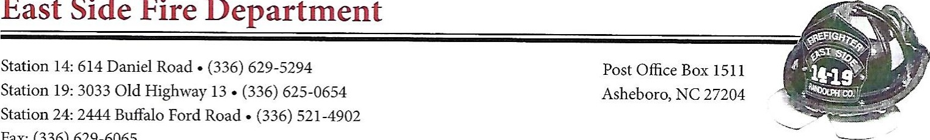One-year probationary period during which time the employee may be dismissed without cause.

**To Apply:**

Prepare a resume with supporting documents (copies of certifications, license, etc) to be reviewed by the Fire Chief. Selected applicants will be notified to schedule an interview. All resumes should be sealed in a manilla envelope.

Resumes may be dropped off to East Side Station 24 located at 2444 Buffalo Ford Rd, Asheboro NC from 8 am to 7 pm.

Resumes may also be mailed:

East Side Fire Department

Attn: Chief Eric Hoffman

PO Box 1511

Asheboro, NC 27204

**Application period shall remain open until position is filled.**