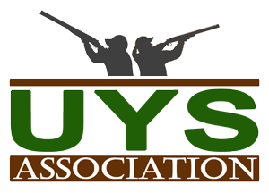

**Place: Farmer Fire Department**

**6881 Old N.C. Highway 49, Denton 27239**

**Meal Times: 4:30 pm – 6:30 pm**

**Silent Auction: 4:30 pm – 6:30**

**Drawings: Start at 7:00 pm**

***You could Win……………………….***

***Perception Prodigy 12’ Kayak Benelli Nova 12 Gauge***

***Mossberg Patriot Predator 243 Camo /Fluted***

***Browning A-Bolt AB3 6.5 Creedmoor Henry Golden Boy .22ir***

***Excalibur Matrix G340 Crossbow Remington 700 SPS .308 Stainless***

***SW M&P 15 Sport II AR – 15/5.56 NATO***

***Berretta A 300 Outlander 12 Gauge***

***Sig Sauer P365 – 9mm Nitron Micro Compact***

***Information or Tickets Contact:***

***Tracy Boyles – 336-302-2574 or tboylesffd@rtmc.net***

**Over $5000 in Prizes!!!**

**GUN BLITZ TICKETS**

**$20 a Book**

**10 Tickets per book!**

**You pick the drawing you want your tickets in – all 10 in one drawing or split them up as you like.**

**Henry Silver Eagle Raffle .17 caliber**

**$5 per ticket or 5 tickets for $20**

**50/50 Cash Raffle**

**Silent Auction**

**Barbeque Dinner**

**All you can eat $10 a plate while it last.**

**Plate includes:**

**Barbeque, Baked Beans, Slaw, Roll, Drink & Dessert**

***3RD ANNUAL***

***Uwharrie Youth Sportsmen***

***Banquet / Gun Blitz***

*Come out and enjoy an evening of fun. Show your support for youth outdoor and shooting sports! The money raised will be used to support Uwharrie Ridge’s Hunter Safety Team and other outdoor recreation activities.*

*FEBRUARY 22nd, 2020 - 4:30 PM to 8:00 PM*