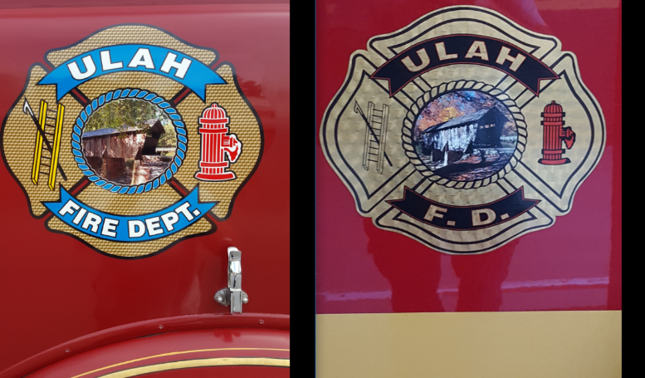 **Ulah Volunteer Fire Department**

**2067 Pisgah Covered Bridge Rd**

**Asheboro, N.C. 27205**

**Phone: (336) 629-1966**

**Position:** Firefighter/Driver

**Department:** Fire

**Salary:** Salary Based on Experience and Certifications

**Closing Date:** Taking Applications For Future Employment

**Benefits:**

* Paid Medical, Dental and Vision Insurance
* SEP Contribution of 4% Retirement Plan
* Training and Education Incentives
* Paid Vacation, Holiday, and Sick Leave
* Firefighters will work a 24-hour rotating shift that requires them to work on some weekends and holidays.
* Firefighters may be required to work in environments with extreme hot and cold temperatures.
* Firefighter may work in situations that may present immediate dangers to the individual’s life and health.
* Firefighters must work well and communicate well with others while performing daily operations of the fire department.

**Minimum Qualifications**

* N.C. Certified Firefighter
* N.C. EMT (Must be obtained within 1 year of hire date)
* N.C. Hazardous Materials Responder – Level 1
* N.C. Emergency Vehicle Driver

Must have a high school diploma/G.E.D. Certificate

Must have a valid N.C. Driver’s License and must have or obtain a Class B license within 6 months of employment

**Applications may be picked up at Ulah Fire Department Station 11**

**2067 Pisgah Covered Bridge RD. Asheboro, N.C. 27205**

**Ulah Volunteer Fire Department is an Equal Opportunity Employer**