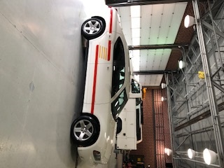**For Sale**

**2008 Dodge Charger Police RWD V8 5.7 L Hemi**

**83,000 Miles**

**Power Locks, Windows and Mirrors**

**Power driver seat**

**Serviced Regularly**

**Runs and looks great**

**Stripping, Emergency Lights, and Siren**

**Selling As Is $8,900.00**

If interested contact Chief Chris White 336-431-2512 at Guil-Rand Fire Department

