**Guil-Rand Fire Department**

Used Scuba Equipment for sale

**Tank**

(Will need service some need new hydro all need visual inspection)

6 Aluminum 19CF pony bottles Catalina $80 each

12 Aluminum 80CF scuba tanks Luxfer & Catalina $80 each

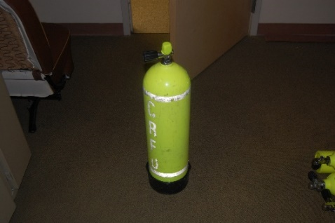 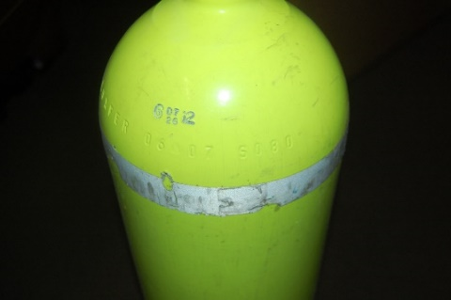

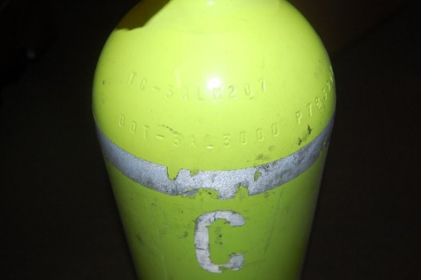 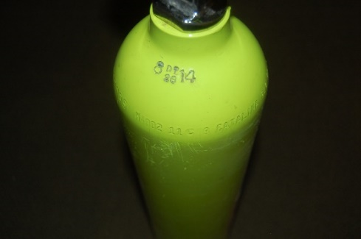

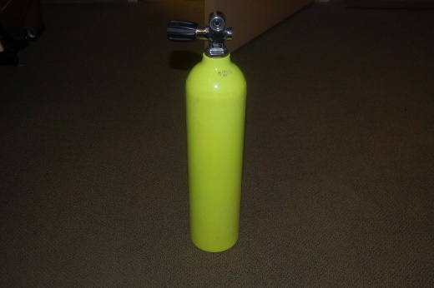 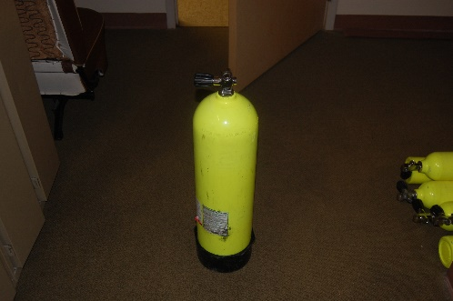

**SCUBA MASK**

Interspiro Divator Mask (will require annual service prior to use)

2 Black with no ambient air valve with Buddy phone $850 each

2 Yellow with ambient air valve with Buddy phone $900 each

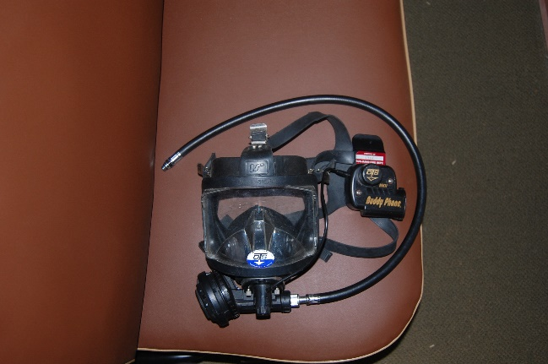 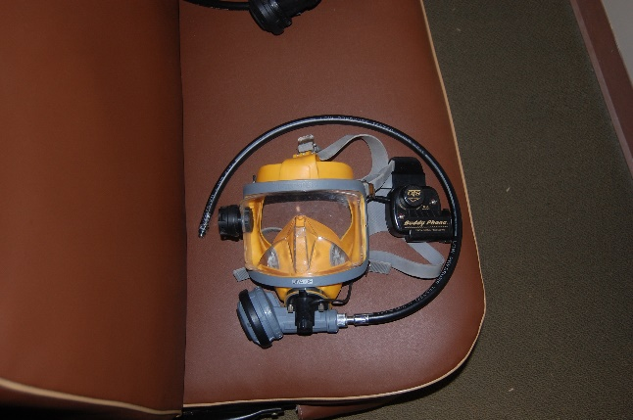

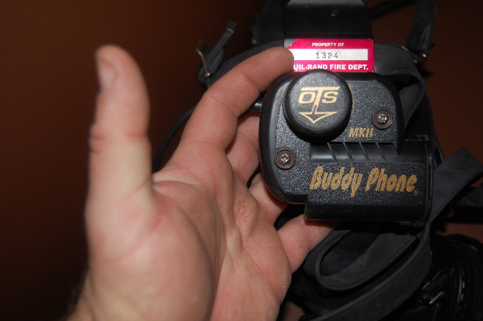 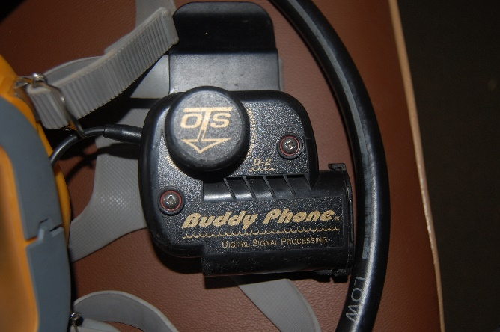

**Switch Blocks**

6 OMNI 2 gas switch blocks $168 each

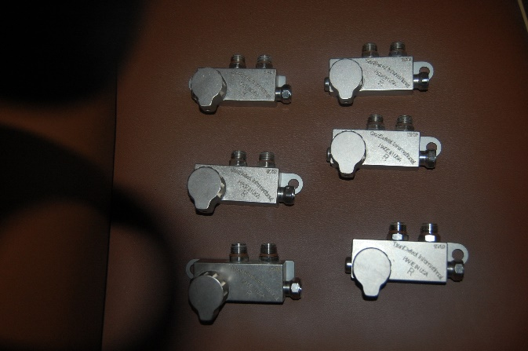

**Dry suits**

Viking Pro Dry suits with HD Hood and undergarment $1400 each

Sizes: 1= #5, 2= #4, 2= #3w, 1= #3

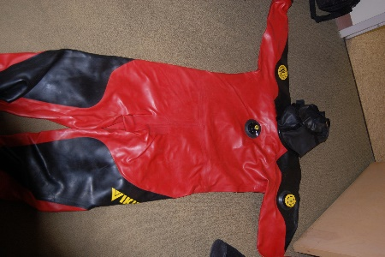 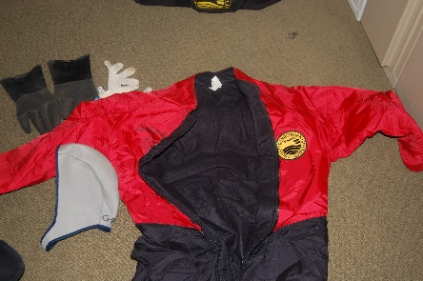 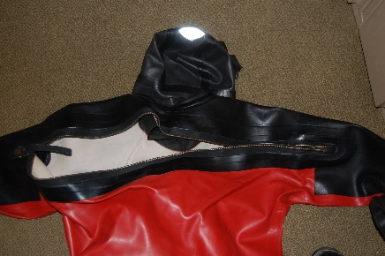

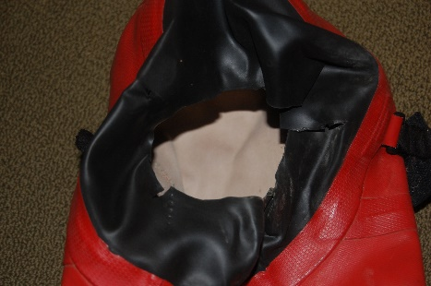 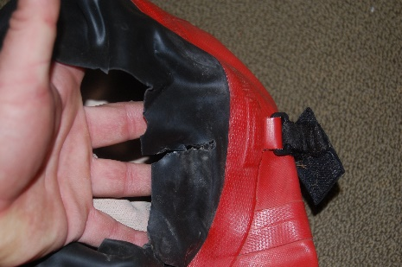 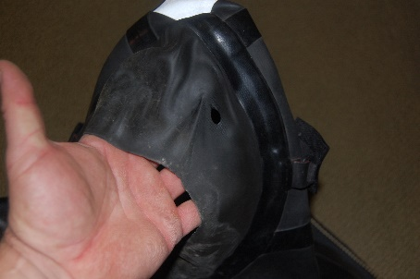

**Regulators**

(All regulators will require annual service prior to use)

3 aqua lung glacia 1st and 2nd stage regulators $250 each

2 Poseidon regulators 1st and 2nd stage

1st stage - Cyclone

2nd stage - Jetstream

6 aqua lung Titan XL 1st stage $100 each

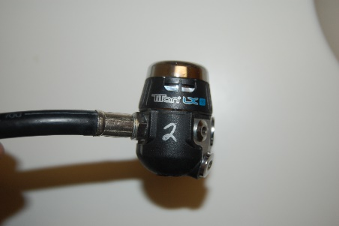 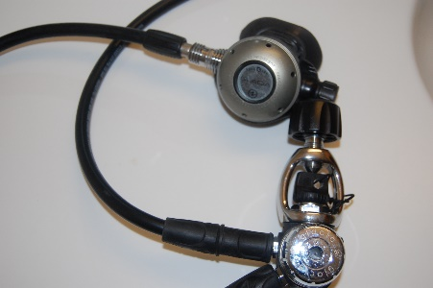 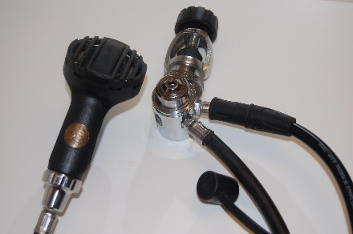

**Consoles**

3 oceanic 3 gauge - depth, pressure, compass $120 each

2 Sherwood 3 gauge - depth, pressure, compass $120 each

6 micro pressure gauges for pony tank regulators $10 each

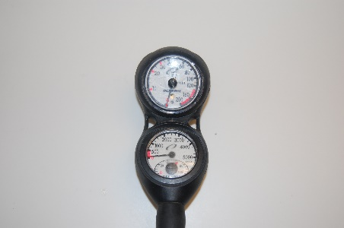 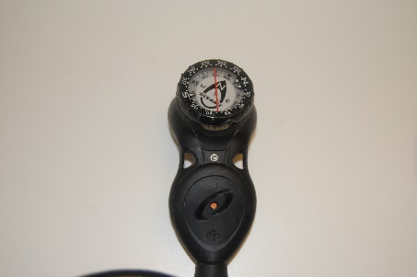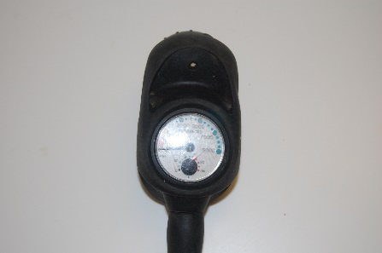 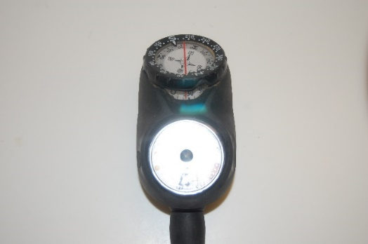

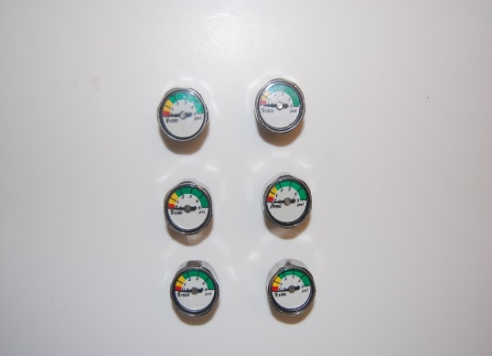

**BCD’s**

**Zeagle Ranger BCD’s**

3 - XL with 65 pound lift bladder and quick release pockets

$ 325 each

2 - L with 44 pound lift bladder and quick release pockets

$ 300 each

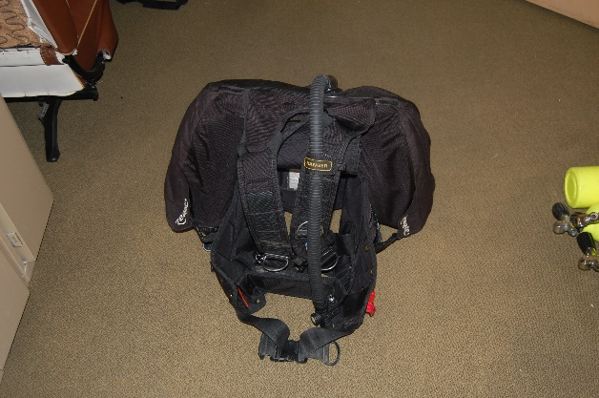 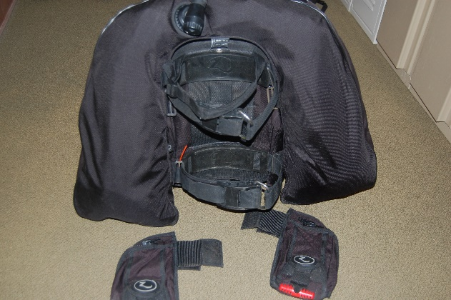

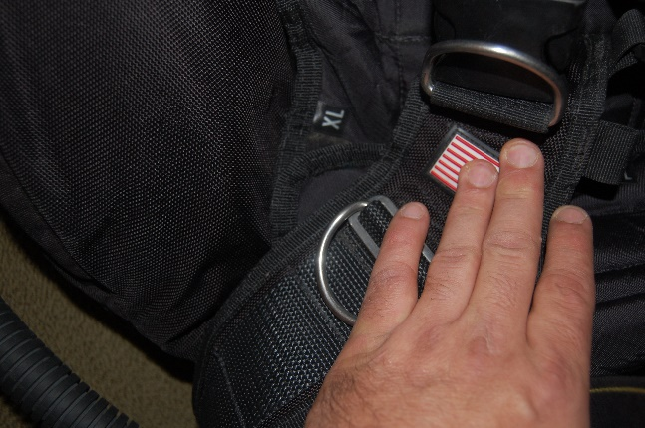 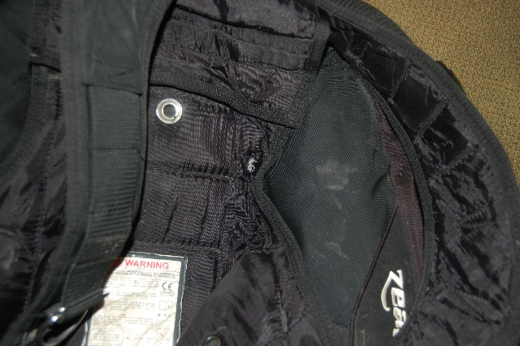

**Fins**

5 sets of XL Turtle fins one set needs replacement straps due to broken straps.

$60 each set and $50 for set with broken straps

2 sets of large rocket fins

$50 each set

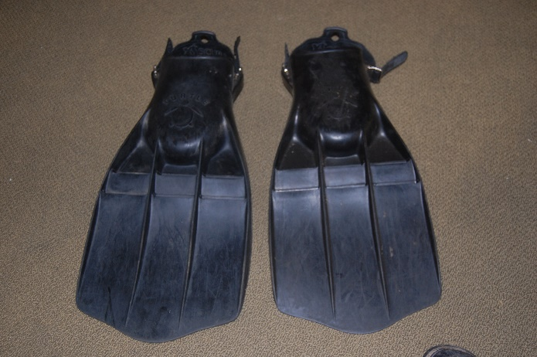 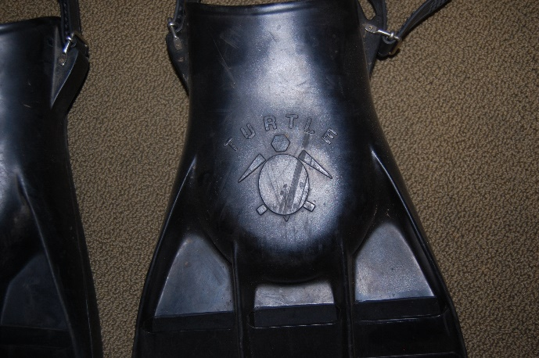

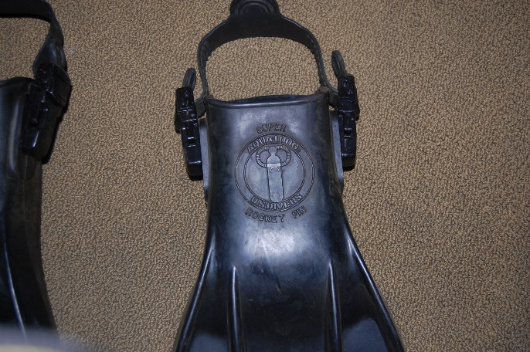 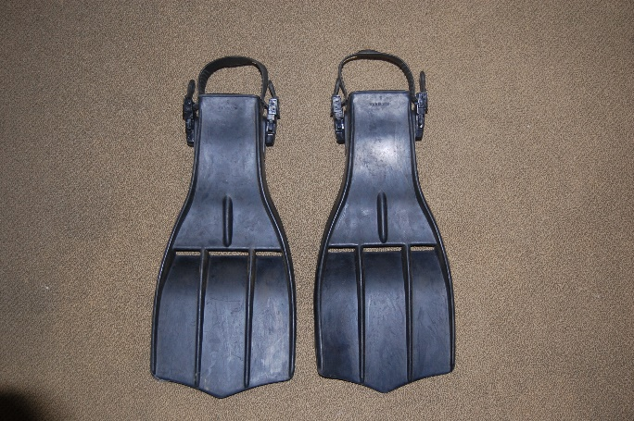

**Other items**

6 pony tank strap sets $40 each/set ~~2 diver below buoy with five flag $10 each~~ ~~2 multipurpose dive reel 150 ft. $10 each~~ 2 XS Scuba 50 pound lift bags $20 each

~~Scuba blunt tip knives $8 each~~

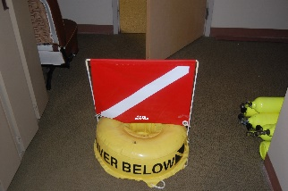 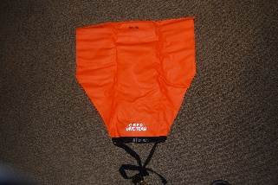 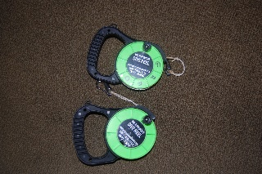 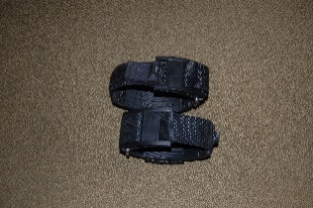

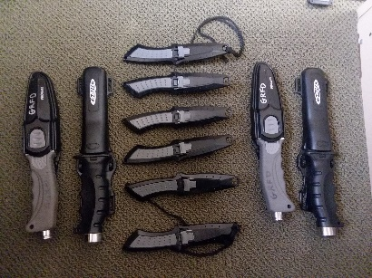 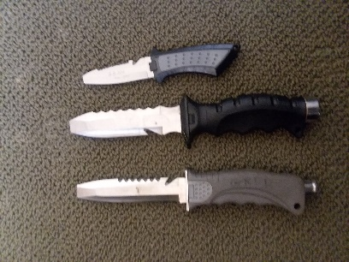

**Weights**

**Soft weight available** 82 pounds

$2.00 per pound

**Hard weight available** 127 Pounds

$1.50 per pound